Another bumper issue of sprinkler stops below!

Autumn Meeting November 2019
South Wales Fire & Rescue Service
We had a well attended Autumn meeting at South Wales Fire & Rescue Service HQ in Llantrisant. First item of business was the presentation of the Bernadette Hartley Memorial Award for 2019. This year the award went to social housing providers Berneslai Homes. Berneslai Homes have been at the forefront of social home providers investing in the safety of their tenants by fitting proactively fitting their building stock with sprinklers. The award was presented to Ken Tann and Kerry Stonar. Fittingly, the award was presented by Ann Jones AM. Ann was the driving force behind the ground breaking Welsh Sprinkler Measure.
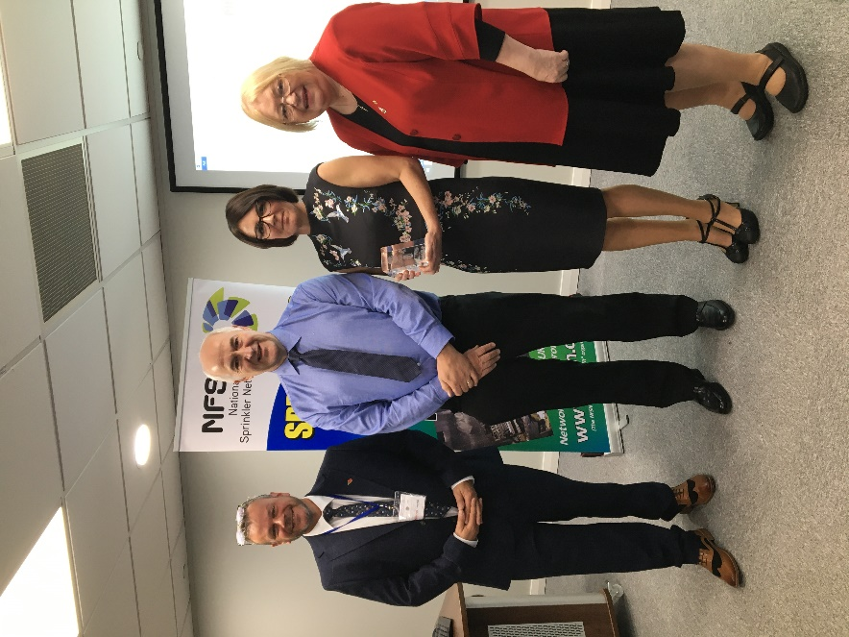
Pictured Terry McDermott, Ken Tann, Kerry Stonar and Ann Jones.
During the meeting we heard about the excellent work going on around the country in saving life and property through fitting sprinklers.
We also received an excellent presentation from Ashley Mather from Staffordshire Fire & Rescue Service of a case study where the fitting of a personal protection system saved the life of a vulnerable individual.
Tom Roche took us through the current work of the Fire Sector Federation and also the highlights of the Approved Document B Clarification document. He also provided an overview of the proposals for the current AD B consultation.
Julian provided an overview of the analysis of data on fires where sprinklers were present for 2018-2019. The statistics continue to support the findings of the Optimal Economics reports from two years ago.
All three presentations have been provided to you with this newsletter.
We also welcomed Gavin Tomlinson, Chief Fire Officer and Chief Executive of Derbyshire Fire & Rescue Service. Gavin has recently taken over the National Fire Chief’s Council Lead for sprinklers and is keen to maintain the close links between the NFCC and the NFSN.
The next meeting will be the AGM and Spring meeting hosted by Dorset and Wiltshire Fire & Rescue Service. 19th March 2020.
Executive Committee Vacancies
NFSN Chair
Terry McDermott recently retired as Chief Fire Officer and Chief Executive of Derbyshire Fire & Rescue Service. Terry was also the National Fire Chiefs Council Lead on sprinklers. At the recent Autumn meeting Terry announced his intention to stand down as Chairman at the next AGM (19th March 2020).
Interested candidates should email their expression of interest to Julian at nfsnsecretary@gmail.com.

We take this opportunity to thank Terry for his strong leadership as our chair.
NFSN Secretary/Treasurer
Julian Parsons recently retired from Buckinghamshire Fire & Rescue Service. At the recent Autumn meeting Julian announced his intention to stand down as Secretary/Treasurer at next year’s AGM.
Interested candidates should email their expression of interest to Julian nfsnsecretary@gmail.com.
The post is awarded a monthly retainer of £750. Reasonable expenses are covered (travelling, subsistence, accommodation,etc).
The post is responsible for maintaining the general communications of the NFSN, the website, organising meetings and managing the financial matters of the network in partnership with the support received from the FPA.
If anyone would like to discuss this post further they can contact Julian either through email or on 07964415055.
Membership News
We welcome back Hall & Kay fire who recently rejoined the network. We also welcome a new member welsh sprinkler installers FSR electrical.

New PDF edition of the LPC Sprinkler Rules launched by the Fire Protection Association
The Fire Protection Association has launched a new PDF version of the sprinklers rules. Their newsletter is attached with this update.

EFSN Newsletter
The latest European Fire Sprinkler Network Newsletter is attached with this newsletter.

Fire Sector Federation News release
The latest Fire Sector Federation News release is attached with this newsletter.

Sprinkler Stops
If any of you are aware of a sprinkler stop or other sprinkler event of interest then please let us know on nfsnsecretary@gmail.com . There is a proforma on our website which will help you provide the essential information we need.
- Flat Fire Southwark Thanks for Colin at Triangle Fire Systems sharing this successful stop.
Nicholas Coleshill at LFB has kindly provided some more background.
- ccupancy: Specialised Housing
- Housing provider; Southwark Council
- Date of incident; 22 October 2019 TOC 10:36
- Location Southwark
- Small fire 3 roomed flat located on the ground floor
- 1 Sprinkler head actuated
- 2 residents evacuated before arrival of brigade
- On arrival fire was all out
- Cause of fire accidental
- BS9251 System

- Seventh Floor Flat Fire in Kent

- Fire in Social Housing in Wales
Leeds restaurant. A fire in a boiler was extinguished by a single head. The restaurant was part of a complex. There was some business interruption but this was due to the work required to fix the boiler. The damage was minimal.
- Fire in converted flats in Essex. Chip pan fire.
Thanks to Mike Sparrow at ECFRS for letting us now about this stop.
The fire occurred in an 8 storey office block converted into 378 flats. The fire happened in a kitchen. The cause was the occupant trying to extinguish a chip pan fire with water (I know…we thought everyone knew that this is a bad idea!). the fire was controlled by two sprinkler heads. The occupant was able to return to the flat after an hour.
Fire in Belway homes house.

Thanks to Daniel Newman from Residential Sprinkler Protection ltd.
The incident happened at a house on a Bellway development at Highfields, Church Road, Old St Mellons, Cardiff, CF3 6YA on the 15th October 2019. The fire service arrived on site 12 minutes after receiving the call. They arrived to find that, thankfully, there was no fire to fight. I have attached some pictures where one head was enough to put out the flame.

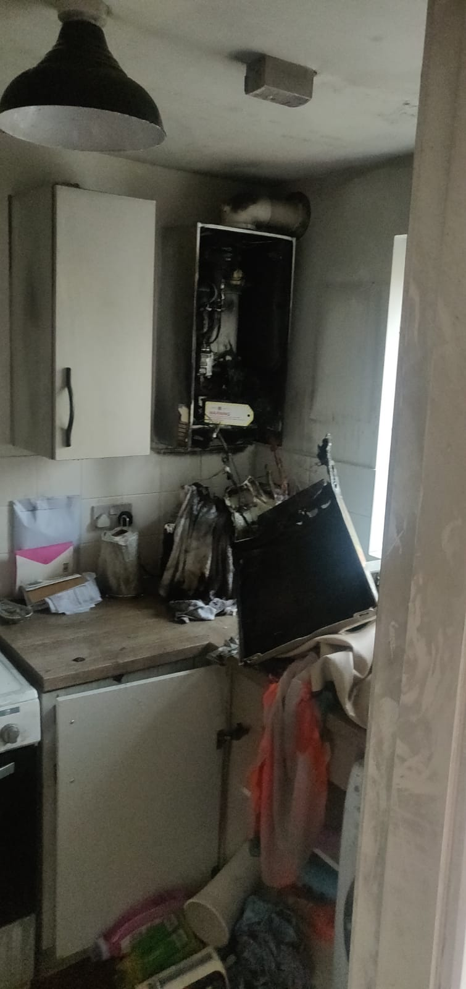

Upcoming Events
2020 NFSN Meetings
Spring Meeting/AGM- 19th March 2020 Dorset and Wiltshire FRS 5 Rivers Health & Wellbeing Centre, Hulse Road, Salisbury, SP1 3NR
Summer Meeting- 3rd June 2020 Essex County Fire and Rescue Service Headquarters, Kelvedon Park, Rivenhall, Witham, Essex, CM8 3HB
Autumn Meeting-Tyne and Wear FRS- 21st October 2020 (provisional date)
Seminars/Conferences
26th November: London

